**AWS**

Create AWS Kubernetes cluster via eksctl:

*eksctl create cluster --name duy-crossplane --region ap-southeast-1*

Helm install Crossplane from Crossplane site

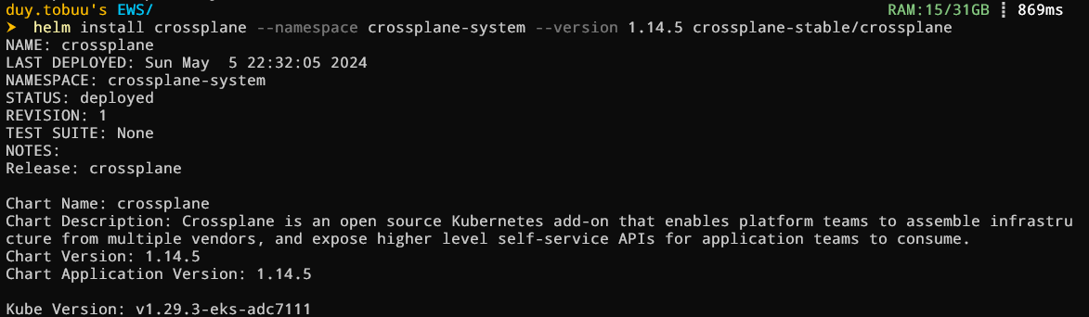

After Helm install complete, check the current cluster on EKS with namespace crossplane-system

EKS Pods status after run Helm install Crossplane

Installing provider-family-aws





Create provider config



Install provider-aws-ec2 provide





Create VPC

Create Internet Gateway



Create Subnets

Create NAT

Create Routes

Install provider-aws-iam



Install provider-aws-eks



Create Role for cluster



Create eks



Create Role for Node group



Create Node group

After Helm install ArgoCD

Crossplane from official Helm chart repository show up in ArgoCD UI

**Azure**

Create Resource Group and AKS cluster

Install Azure Provider



Config Azure Provider



Create Azure creds

Create Resource Group



Install provider-azure-network

Create Virtual Network



Create Subnets



Install provider-azure-containerservice



Create AKS



